**Reviewer Web Application**

**Business Requirements Document**

**Project**: Reviewer Web Application

**Author(s):** Sanjeev Kumar S K, Bisheng Zeng, Nayan Yadav, Kaushal Dobbariya, Vaibhav Babbariya, Prasad Menda, Sai Kiran, Vignan Kasam

Table of Contents

**1.** **Project Overview** 3

**2.** **Document Information** 3

2.1 Audience 3

**3.** **Business Opportunity** 3

3.1 Project Overview and Background 3

3.2 Current State Analysis 4

3.3 Future State Objectives 4

3.4 Business Domain Model and Stakeholders 4

**4.** **Business Requirements** 4

4.1 Details of Business Requirements 5

**5.** **Non-Functional Requirements** 6

**6.** **External Data Feeds** 7

**7.** **Business Risks** 8

# **Project Overview**

This document describes the business/user requirements for the Reviewer applications that will provide the basis for the following project activities:

* Introducing business/user requirements
* Creating test plans and test specifications
* Identifying stakeholders
* Devising solutions to project tasks
* Produce an application that will enable users to subscribe to various subscription plans and receive the healthy products that are easy to prepare at their doorsteps.
* Determining when the project is complete
* Assessing the degree to which the project succeeded

# **Document Information**

## 2.1 Audience

| Name | Business Group | Role |
| --- | --- | --- |
| Merchant stores | Merchant stores management | Partners/Suppliers |
| Subscriptions | Subscription Account management | Partners/Suppliers |
| Finance | Finance management | Partners/Suppliers |
| Advertisement | Advertisement sales management | Partners/Suppliers |
| Customers | User Management | Web Application Users |

# **Business Opportunity**

## 3.1 Project Overview and Background

Reviewer is a local life information and trading platform, and an independent third-party consumer review website. Reviewer not only provides users with information on merchants, consumer reviews, and consumer offers, but also provides group buying, booking tickets, merchant information, and other transaction services. It also focuses on food and shopping. It also co-operates with Google Maps to gradually expand its business to the travel market. Users can post experiences under each merchant, and they can also post a story about it and attach pictures about it.

## 3.2 Current State Analysis

Most people often need to consider spending options in their daily lives, including restaurants, scenic, travel, and entertainment due to busy lifestyles and hectic work schedules. Reviewer provides a local life information and trading platform, an independent third-party consumer review website. It not only provides users with information on merchants, consumer reviews, and consumer offers, but also provides restaurant booking, booking tickets, merchant information, and other transaction services. The project will be written in JAVA, Python and JavaScript and will use a relational database produced by SQL. The planning process for the application is currently underway, and the development of the project will span two semesters at Pace University.

## 3.3 Future State Objectives

The objective is to create a web application that will be able to compete in the crowded marketplace of rating websites. The web application will offer a variety of ratings, reviewing, and finding satisfying options from merchants, thus users are able to determine destinations based on websites’ information for merchants. Users will also gain value from the website due to the authentic reliability of other users and provide real user reviews based on their own experience.

## 3.4 Stakeholders

| Stakeholders |
| --- |
| Management and Executives |
| Merchants |
| Advertising Agency |
| Payment merchants |

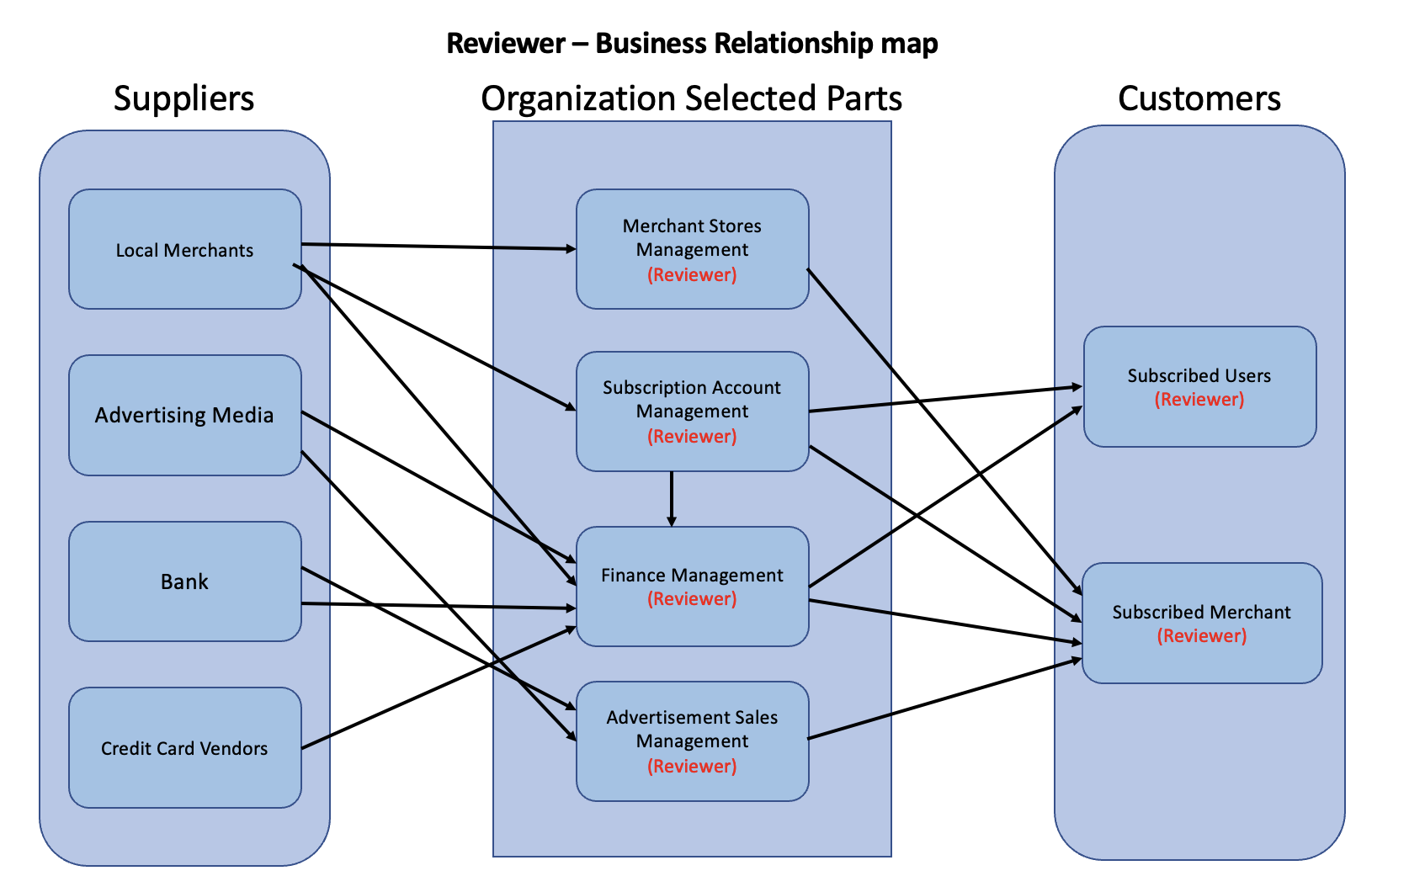

# **Business Requirements**

The project includes four main functional areas: Subscription/Account Management, Merchant Store Management, Finance Management and Advertising Sales Management. The Subscription/Account Management functional area includes creating, editing, and deleting user and merchant accounts, processing plan subscription payments, and providing customer support for account-related inquiries. The Merchant Store Management functional area allows for managing merchant accounts, including creating, editing, and deleting accounts and providing customer support. The Finance Management functional area handles processing payments, including merchandise payments and plan subscription payments for users and merchants. The customer requirements include account management features, accessing exclusive content, personalized recommendations, favorite business organization, discounts, feedback and support features, and the ability to view and compare prices from different merchants on a map view.

## 4.1 Details of Business Requirements

* + 1. **Subscription/ Account Management**
       1. Ability to create a new user account
       2. Ability to sign-in in User account
       3. Ability to edit user account information
       4. Ability to delete a user account
       5. Ability to reset user account password
       6. Ability to view user account activity
       7. Ability to deactivate/reactivate user accounts
       8. Ability to provide customer support for user account-related inquiries
    2. **Merchant store management**
       1. Ability to create a new merchant account
       2. Ability to sign-in in Merchant account
       3. Ability to edit merchant account information
       4. Ability to delete a merchant account
       5. Ability to reset merchant account password
       6. Ability to view merchant account activity
       7. Ability to deactivate/reactivate merchant accounts
       8. Ability to provide customer support for merchant account-related inquiries
    3. **Finance Management**
       1. Ability to process payments for merchandise sales and subscription plans for users and merchants
       2. Ability to process refunds in case of lost orders or issues with products
       3. Ability to manage and track billing and invoicing for users and merchants
       4. Integration with multiple payment gateways for credit card processing
    4. **Advertisement Sales Management**
       1. Ability to display ads
       2. Ability to process payments for advertising sales
       3. Ability to process plan subscriptions for merchants
    5. **Customer Requirements**
       1. Ability to create an account.
       2. Ability to delete the account.
       3. Ability to modify the account information.
       4. Ability to restore the password/user ID details.
       5. Ability to sign in to (sign out from) already created account.
       6. Ability to access content, such as exclusive reviews and ratings.
       7. Ability to view enhanced business information, including more detailed menus, photos, and videos.
       8. Ability to filter search results based on additional criteria.
       9. Ability to receive personalized recommendations based on past searches and preferences.
       10. Ability to save and organize favorite businesses into custom lists.
       11. Ability to view and redeem exclusive discounts and deals.
       12. Ability to leave more detailed and informative tips for other users.
       13. Ability to access advanced customer support features, such as priority response times and live chat support.
       14. Ability to Book Hotels or Events
       15. Ability to Cancel Hotels or Events
       16. Ability to view and compare prices from different merchants for a particular service.
       17. Ability to see past booking history and leave feedback on the overall experience.
       18. Ability to access a map view of available businesses and filter based on location.

# **Non-Functional Requirements**

| **Category** | **Requirements** |
| --- | --- |
| **Usability** | The application GUI will provide a user-friendly intuitive design with all the features clearly displayed for the user |
| **Usability** | The application navigation will be self-explanatory by clear and concise descriptions and names of each section, as well as features will be clearly evident by proper location and naming |
| **Usability** | Accessibility will be supported for the disabled users as well |
| **Performance** | The application will be supported on different operating systems and browsers, and should not impact the user’s system capabilities |
| **Performance** | The application will be available for 24/7 without any interruptions, and regular maintenances will be scheduled to support the application |
| **Performance** | The application will support the concurrency where the users will be able to simultaneously browse the app, login & subscribe, make payments, shop the products |
| **Performance** | The application will have short response time to all requests and all the features should be available and not impacted by latency |
| **Security** | The application will be using the automated daily & weekly audits to detect the vulnerabilities. |
| **Security** | The application will use HTTPS protocols for any data exchanges, enforced TLS for all the email communications, and other encryptions that will be maintained on the server |
| **Database** | The application will be using the MySQL database |
| **External System** | The application will be able to interface with the external data feeds from and to payment merchants, ad agencies, social media websites, etc… |

# **External Data Feeds**

* **Payment System**
  + Allows customers to pay for subscriptions and merchandise, and process refunds when necessary by charging and crediting back funds to credit cards or other payment methods.
* **Map System**
  + Locates restaurants, hotels, and event locations and enables users to access their current location.
* **Hotel System**
  + A system that enables a hotel or group of hotels to manage front-office capabilities, such as booking reservations, guest check-in/checkout, room assignment, managing room rates, and billing.
  + The system should also allow customers to view room availability, amenities, and photos, as well as make reservations and payments.
* **Event System**
  + A system that provides information about upcoming events, such as conferences, concerts, and shows.
  + The system should allow customers to view event details, including the venue, date, time, and ticket availability.
  + Customers should also be able to purchase tickets and receive electronic tickets for entry to the event.
  + The system should also allow event organizers to manage event details, including ticket sales, attendee lists, and event logistics.
* **Ads Management System**
  + Feeds the application with sponsored posts, contract length, and costs of advertisements.
  + Generates reports for trend analysis and market performance to feed into the Ads Platform system**.**

# **Business Risks**

The review industry refers to businesses that provide reviews of products, services, or experiences, either through traditional media channels like newspapers and magazines or through online platforms such as blogs, social media, and review sites. Business risk in the review industry can arise from various factors, including

**Reputational Risk:** Review businesses depend heavily on their reputation for providing accurate, unbiased, and trustworthy reviews. If a review business fails to maintain its reputation, it can lose the trust of its readers or viewers, which can lead to a decline in readership or viewership and ultimately impact the business's revenue.

**Legal Risk:** Review businesses must ensure that their reviews comply with applicable laws and regulations. For example, they must avoid making defamatory statements or violating copyright or trademark laws. Failure to comply with legal requirements can result in lawsuits and significant financial penalties.

**Competition Risk:** The review industry is highly competitive, and new players can enter the market at any time, providing similar or better services. Review businesses must continually innovate and differentiate themselves from their competitors to maintain their market share.

**Business Model Risk:** Review businesses often rely on advertising revenue or affiliate marketing to generate income. Changes in the advertising market, such as the shif towards digital advertising, can significantly impact revenue streams, and review businesses must adapt to these changes quickly.

**Cybersecurity Risk:** As review businesses operate primarily through digital channels, they are vulnerable to cyber-attacks such as data breaches, phishing attacks, and malware infections. These attacks can result in the loss of sensitive data, reputational damage, and financial losses.

Overall, business risk in the review industry is significant and varied, and review businesses must continually monitor and manage these risks to ensure their long-term success.